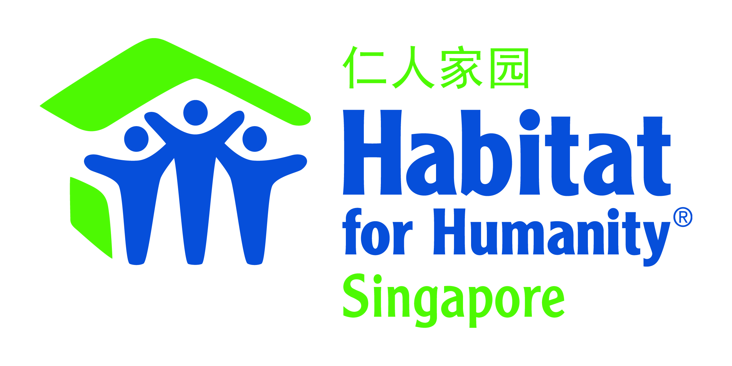
REFERRAL FORM for PROJECT HOMEWORKS
At Project HomeWorks, we work with vulnerable persons and families in Singapore who need help to transform their homes into a safe and sanitary state.

Depending on the need, Project HomeWorks assists homeowners in one or more of following ways:
- Eliminating pest infestation including professional pest control services and replacing pest-infested furniture (basic items only, e.g. beds)
- Intensive cleaning & re-organising
- Painting for badly stained/ peeling wall and ceilings, and rusty front gates

Each Project HomeWorks session usually runs from 9am till about 2pm, and is led by staff, powered by volunteers. Please note that we do NOT provide light or regular housekeeping.

OUR GUIDELINES FOR CASE SELECTION
Personal Motivation & Ability
- Willing and able to work with our staff and volunteers for sustainable transformation.
- Please note that we are unable to assist homeowners with a history of verbal abuse or physical
assault, or if they have substance addiction or infectious health conditions.
Home Environment
- Lives in 1- or 2-room HDB flats under the Public Rental Scheme (for applicants living in purchased flats, priority will be given to those under ComCare Assistance).
- Home environment is in need of major improvement/rehabilitation works.
Financial/Social Situation
- Lacks financial means for the home rehabilitation works needed.
- Has little or no support from able family members.

For cases involving hoarding issues and/or persons with mental disabilities, we will require the client’s social worker/case manager/counsellor to be onsite during the sessions.

UPHOLDING OUR HOMEOWNERS’ PRIVACY
Habitat for Humanity Singapore respects your client's privacy. We will never share their personal details with unauthorised parties and will only selectively disclose information on a need-to-know basis. We strictly adhere to guidelines of the Personal Data Protection Act under the laws governing Singapore. As your client's security is important to us, we take reasonable steps to protect their personal information against risks such as theft, loss, unauthorised access, destruction, use, modification and disclosure. The personal information collected in this form will only be used and disclosed with related third parties for the purpose(s) for which it was collected, namely to facilitate the intensive cleaning operations in their home with the help of staff and volunteers, manage relationships with them, reporting to our donor or sponsors and comply with any requirements by law.

Referrer Information
Referral Date: |  | Referring Organisation:
Contact Info of Referring Person: | Name of Referring Person Designation  Email  Office No. Mobile No.

HOMEOWNER’S PRIVACY CONSENT
By submitting the form, you (the referrer) hereby confirmed that:
- Your client has been notified of the purpose and has consented to the collection, use, and disclosure of their personal data by Habitat for Humanity Singapore.
- You will be able to show proof of your client’s consent if required by the authority.

Please state type of consent obtained from client: | Written Oral Other:

Your Client’s Personal Information
Name: |  |  |  |  |  | NRIC: |  | (need last 4 digits only)
Gender: | Male  Female |  |  | Birth  Year: | YYYY | Contact Number:
Languages/  Dialects spoken: |  |  | English Mandarin Malay Tamil Hokkien Teochew  Cantonese Other:
Address: | Block & Street Name Unit No. Postal Code
HDB Type: |  | 1-room 2-room 3-room  Other: |  |  |  | Rental flat Purchased flat
Income  Sources: | ComCare Long-term (Public Assistance) Savings  CPF Allowance from family Salary  Others (e.g. ComCare Short-term, Silver Support, etc):  Please type description here |  |  |  |  |  |  |  |  |  | Amount received per Month:
Marital Status: | Single Widowed Married  Divorced/Separated |  |  |  |  |  | No. of Children: |  |  |  |  | No. of  Siblings:
Describe how the children/siblings are supporting the client (financially/socially):
Please type description here

Housing & Financial Information of household
Living Arrangement: | Lives alone With flatmate/friend  With family Other: |  | Total No. of Pax  living together:  (Including client)
Household’s Vaccination Status: |  | Fully vaccinated Not vaccinated * Other:  * For unvaccinated homeowners (by choice or with medical exemption), please complete waiver of liability form located at the last page of this form.
List occupants (name, age and relationship with main client):
Please type description here

YOUR CLIENT’S Functional AbilitY & resources
Physical ability:  Mental ability:  Emotional state: | Good Some impairment Severe impairment  Good Confused/forgetful Diagnosed with mental disability  Good Moody/unmotivated Diagnosed with mental illness
Community Services Currently Received: |  | Housekeeping Home medical/nursing  Laundry Daycare  Befriending Counselling  Other(s):
Please advise if the Community Services are still ongoing or have they been suspended due to the home condition?
Please type description here

Your Recommendations for our assistance
1. Pest Control Service | Yes No Maybe/ Unsure
 | Type(s) of pests identified: |  |  | Bedbugs Cockroaches  Other: Please type description here
 | Guide to identifying bedbugs: https://www.epa.gov/bedbugs/how-find-bed-bugs
2. Decluttering/  Re-organising Service | Yes No Maybe/ Unsure
 | Refer to Clutter Image Rating Scale: http://www.hoardingconnectioncc.org/Hoarding_cir.pdf
Current clutter level (based on most severe area of house):
Light (1 to 3) Medium (4 to 6) Extreme (7 to 9)

3. Intensive Cleaning | Yes No Maybe/ Unsure
 | Area(s) of house: Please type description here
4. Painting  (for stained/ peeling/ rusty walls & surfaces only) | Yes No Maybe/ Unsure
 | Area(s) of house: Please type description here
Current paint condition (based on most severe area of house):
Good Some stains Badly stained/peeling

Describe the challenge(s) that your client is facing in managing the condition of the house (include any medical conditions/ailments):
Please type description here

Have you/your client previously approached other organisations/ services for the works needed? |  | Yes | Please state name of organisation and type of services requested/received: Please type description here
 |  | No | Please state why: Please type description here
Have you managed to secure agreement from your client’s family members (especially adult children) to support the works needed:

Financially: Yes N/A (no family members) No (why: )
Physically: Yes N/A (no family members) No (why: )

Your assessment on your client and his/her family & household’s financial ability for the needed works:
Please type description here

Describe your long-term care plan for the client to upkeep the condition of their house after Project HomeWorks has been completed:
Please type description here

ALTERNATIVE CONTACT PERSON (MEMBER OF FAMILY/ HOUSEHOLD)
Name Relationship Age

Home No. Mobile No.

Please attach photos of general living conditions IN THE NEXT PAGE
Photos are required. We will not be able to process any referrals without photos.

photos of general living conditions
Photos are required. We will not be able to process any referrals without photos.
Living Hall | Bedroom/ Bed Area
Kitchen | Toilet
Other Areas of House: Please type description here | Other Areas of House: Please type description here

Other Areas of House: Please type description here | Other Areas of House: Please type description here

FOR UNVACCINATED HOMEOWNERS: Please COMPLETE Waiver of Liability Form IN THE NEXT PAGE.
We will not be able to process any referrals for unvaccinated homeowners without the completed waiver form.

TIP: To prevent delay to the referral process, please ensure your form is fully completed before emailing it to info@habitat.org.sg

Our Referral Process (This process spans across 4 to 6 weeks depending on our case load)

Step 1: Initial Assessment | Upon receiving your partnership request or referral
Step 2: Joint home visit | Detailed assessment of the household and their needs
Step 3: Book services | Prepare and schedule needed services
Step 4: Confirm schedule| Agree on date/time and list of works.
Step 5: Execute Project | Execute the Project HomeWorks session(s)
Step 6: Post-Session | Debrief on outcome and any needed follow-up.

WAIVER OF LIABILITY RELATING TO COVID-19
(for unvaccinated Homeowners requiring Project HomeWorks’ services)
At Project HomeWorks, we work with vulnerable persons and families in Singapore who need help to transform their homes into a safe and sanitary state. More details at: http://www.habitat.org.sg/project-homeworks

Amidst the COVID-19 pandemic, our operations continue to serve the vulnerable in the community who need a decent place to live in.

COVID-19 is reported to be extremely contagious. The state of medical knowledge is evolving, but the virus is believed to spread from person-to-person contact, by contact with contaminated surfaces and objects, and even possibly in the air. People reportedly can be infected and show no symptoms, therefore spreading the disease unknowingly. The exact methods of spread and contraction remains largely unknown, but evidence has shown that COVID-19 can cause serious and potentially life-threatening illness and even death, especially to unvaccinated individuals.

While strict measures and care have been taken to minimize the incident of spreading the COVID-19 virus to the vulnerable community, Habitat for Humanity Singapore cannot prevent you [and/or your household member(s)] from becoming exposed to, contracting, or spreading COVID-19 while utilizing Habitat for Humanity Singapore’s services under the Project HomeWorks programme. It is not possible to prevent against the presence of the disease. Therefore, if you choose to utilize Habitat for Humanity Singapore’s services, you [and/or your household member(s)] may be exposing yourself to and/or increasing your risk of contracting or spreading COVID-19.

ASSUMPTION OF RISK: I have read and understood the above warning concerning COVID-19. I hereby choose to accept the risk of contracting COVID-19 for myself and/or my household member(s) in order to utilize Habitat for Humanity Singapore’s services. These services are of such value to me [and/or to my household member(s)] that I accept the risk of being exposed to, contracting, and/or spreading COVID-19 in order to utilize Habitat for Humanity Singapore’s services under the Project HomeWorks programme.

WAIVER OF LAWSUIT/LIABILITY: I hereby forever release and waive my right to bring suit against Habitat for Humanity Singapore and its owners, officers, directors, managers, officials, trustees, agents, employees, or other representatives in connection with exposure, infection, and/or spread of COVID-19 related to utilizing Habitat for Humanity Singapore’s services. I understand that this waiver means I give up my right to bring any claims including for personal injuries, death, disease or property losses, or any other loss, including but not limited to claims of negligence and give up any claim I may have to seek damages, whether known or unknown, foreseen or unforeseen.

CHOICE OF LAW: I understand and agree that the laws of Singapore will apply to this contract.

I HAVE CAREFULLY READ AND FULLY UNDERSTAND ALL PROVISIONS OF THIS RELEASE, AND FREELY AND KNOWINGLY ASSUME THE RISK AND WAIVE MY RIGHTS CONCERNING LIABILITY AS DESCRIBED ABOVE:

Homeowner’s Signature Date

Homeowner’s Name

I am the legal public guardian of the homeowner named above. I have the legal right to consent to and, by signing below, I hereby do consent to the terms and conditions of this Release.

Guardian’s Signature Date

Guardian’s Name

